Supplementary Materials:

To provide a practical case study for the strategies proposed in this paper, this study includes the instructional design and assessment tools from the author's course, "Methods and Tools for Information System Development." These materials demonstrate how to guide students in the responsible use of AI and conduct in-depth assessments of their learning processes within a real-world educational setting. All materials have been anonymized to protect student privacy. All supplementary materials are stored in the following public repository:

List of Contents:

1. Course Slides and AI Usage Guidelines: Detailed course lecture slides, accompanied by a clear "AI Tool Usage Policy" for each lab session, which stipulates when and how students may use AI in their assignments.
PDF File: Methods and Tools for Information System Development Course Slides and AI Usage Guidelines .pdf

2. Rules and Requirements: Lab rules and final project requirements documents. These include lab rules designed to encourage creativity and assess higher-order thinking skills, as well as requirements for the "open-ended" final project.
(1) Lab Rules Documentation: lab-rules.ppt
(2) 2025 Methods and Tools for Information System Development Final Project Requirements.pdf

3. Assignments and Grading Feedback: Includes lab documentation, final reports, and assessment feedback forms (which include AI interaction logs, reflections, and the final product):
(1) Lab Documentation: There were 19 groups in the course. One group (Group 5) is selected as a representative example. The 16 lab documents from this group have been consolidated and anonymized: Group 5 Lab Documentation.pdf
(2) Final Report (Final Product): Group 5 Final Report.pdf
(3) Grading Feedback Sheet: InfoMgt Class Lab Grading Feedback Sheet.xlsx

补充材料：
为了提供本文所提策略的实践案例，本研究提供了作者开设的“信息系统开发方法与工具”课程的教学设计与评估工具。这些材料展示了如何在真实的教学环境中，引导学生负责任地使用AI并对其学习过程进行深入评估。所有材料均已进行匿名化处理，以保护学生隐私。所有补充材料均保存在以下公共存储库中：

内容清单：

- 课程讲义与AI使用规范：详细的课程教学讲义，以及配套每次实
验的一份明确的“AI工具使用规范”，该规范规定了学生在作业中何时以及如何使用AI。
PDF文件：信息系统开发方法与工具 课程讲义与AI使用规范.pdf
- 规则与要求：实验规则和期末结课要求文档，鼓励创造性并评估高阶思维能力的实验
规则和“开放
式”的项目作业(期末结课)。
要求。
（1）实验规则说明文档：lab-rules.ppt
（2）2025年信息系统开发方法与工具期末结课要求.pdf
- 作业与评分反馈：包括实验文档、期末报告以及评估反馈表（其中包括AI交互记录、反思和最终成品）：
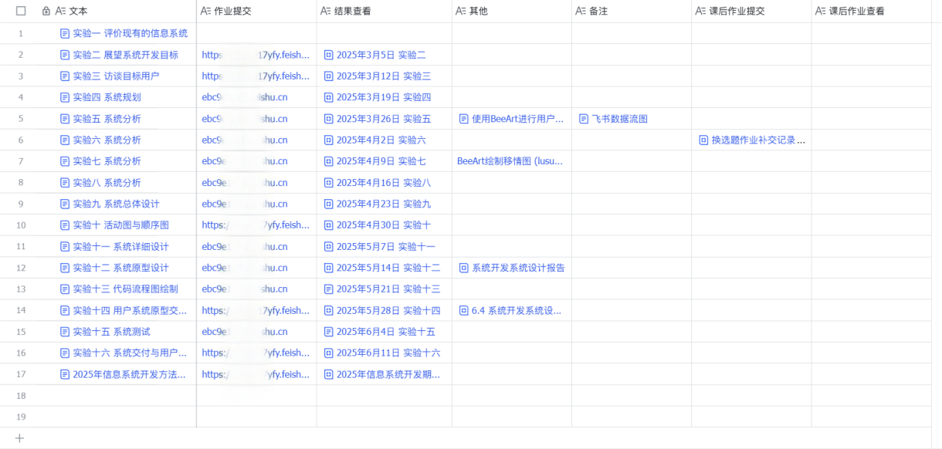

- 实验文档：每次实验，实验共19组，选取其中一组为代表，以其中一组为例（第五组），将16次实验文档合并，整理相关匿名化材料：第五组 实验文档.pdf
- 期末报告（最终成品）：第五组 期末报告.pdf
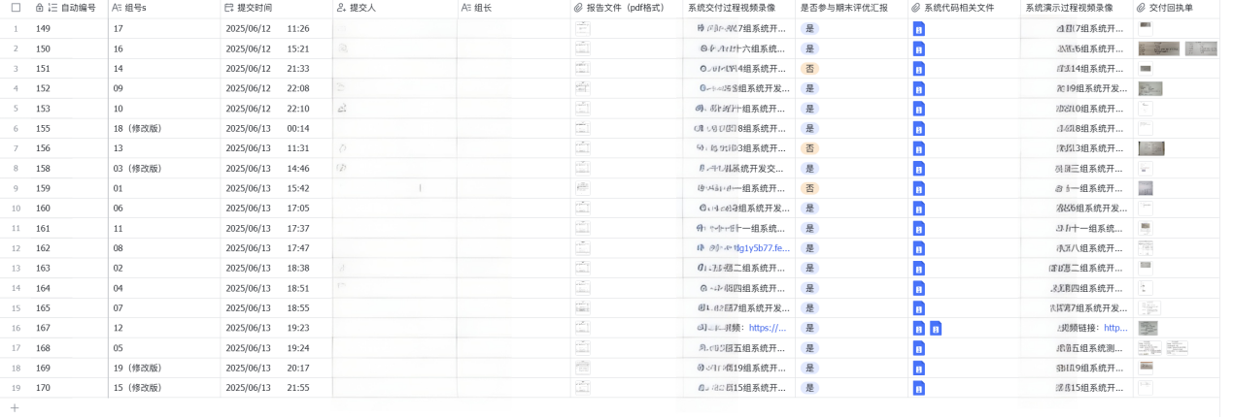
- 评分反馈表：信管##班 实验 评分反馈表 xlsx

